**Introduction**

1. **Simple Program**

General Form of a Program:

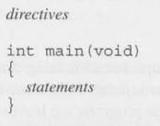

* **Example:**

|  |  |
| --- | --- |
| 1  2  3  4  5  6  7  8  9  10  11  12  13  14 | */\**  *\* Name: Bismillah.c*  *\* Purpose: Basic program to simulate fundamentals of C*  *\* Author: Kalim Amzad*  *\* Date: 24-03-2018*  *\*/*  #include <stdio.h>  **int** main(**void**) */* Beginning of main program */*  {  printf("Bismillahir Rahmanir Rahim**\n**"); *// Simple printf*  **return** 0;  } |

* **Explain directives and main function:**
* **Compiling and Linking:**

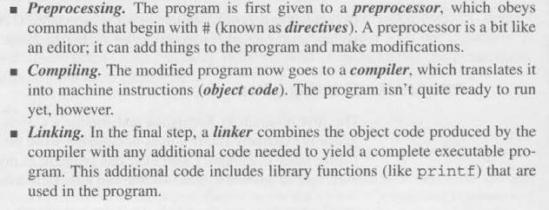

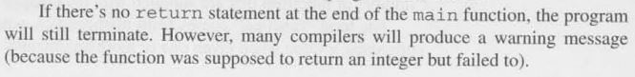

* **Changing printf statement:**

printf("Bismillahir");

printf("Rahmanir");

printf("Rahim");

printf("Bismillahir**\n**Rahmanir**\n**Rahim");

printf("Bismillahir**\n**");

printf("Rahmanir**\n**");

printf("Rahim**\n**");

* **Explaining Comment:**

1. **Keywords**

Keywords are predefined, reserved words used in programming that have special meanings to the compiler. For example:

int money;

Here, int is a keyword that indicates 'money' is a variable of type integer.

As C is a case sensitive language, all keywords must be written in lowercase. Here is a list of all keywords allowed in ANSI C.

|  |  |  |  |
| --- | --- | --- | --- |
| Keywords in C Language | | | |
| auto | double | int | struct |
| break | else | long | switch |
| case | enum | register | typedef |
| char | extern | return | union |
| continue | for | signed | void |
| do | if | static | while |
| default | goto | sizeof | volatile |
| const | float | short | unsigned |

Along with these keywords, C supports other numerous keywords depending upon the compiler.

* **Identifiers**

Identifier refers to name given to entities such as variables, functions, structures etc.

int money;

float accountBalance ;

Here, money and accountBalance are identifiers.

Also remember, identifier names must be different from keywords. You cannot use int as an identifier because int is a keyword.

**Rules for writing an identifier**

1. A valid identifier can have letters (both uppercase and lowercase letters), digits and underscores.
2. The first letter of an identifier should be either a letter or an underscore. However, it is discouraged to start an identifier name with an underscore.
3. There is no rule on length of an identifier. However, the first 31 characters of identifiers are discriminated by the compiler.

**Valid identifiers:**

X Y12 sum-1 _temperature

Names area tax-rate TABLE

**Invalid identifiers for the reasons stated:**

4th The first character must be a letter.

“x “ Illegal characters (“).

order-no Illegal character (-).

error flag Illegal character (blank space).

1. **Data Type:**

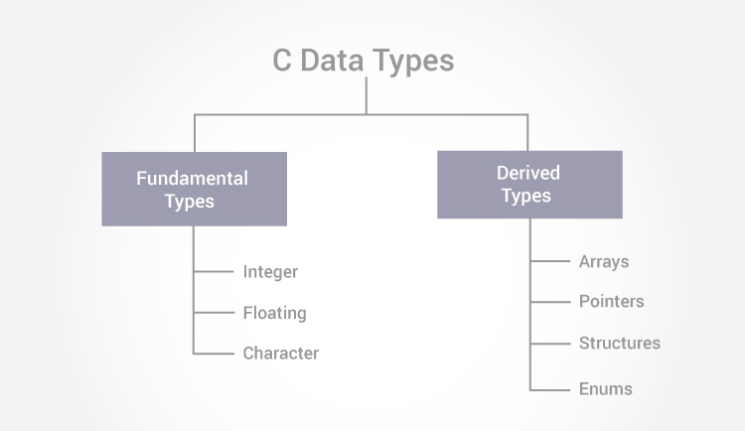

* **Integer Types**

The following table provides the details of standard integer types with their storage sizes and value ranges –

|  |  |  |
| --- | --- | --- |
| **Type** | **Storage size** | **Value range** |
| char | 1 byte | -128 to 127 or 0 to 255 |
| unsigned char | 1 byte | 0 to 255 |
| signed char | 1 byte | -128 to 127 |
| int | 2 or 4 bytes | -32,768 to 32,767 or -2,147,483,648 to 2,147,483,647 |
| unsigned int | 2 or 4 bytes | 0 to 65,535 or 0 to 4,294,967,295 |
| short | 2 bytes | -32,768 to 32,767 |
| unsigned short | 2 bytes | 0 to 65,535 |
| long | 4 bytes | -2,147,483,648 to 2,147,483,647 |
| unsigned long | 4 bytes | 0 to 4,294,967,295 |

To get the exact size of a type or a variable on a particular platform, you can use the **sizeof** operator. The expressions *sizeof(type)* yields the storage size of the object or type in bytes. Given below is an example to get the size of int type on any machine −

printf("Storage size for int : %d \n", sizeof(int));

* **Floating-Point Types**

The following table provide the details of standard floating-point types with storage sizes and value ranges and their precision −

|  |  |  |  |
| --- | --- | --- | --- |
| **Type** | **Storage size** | **Value range** | **Precision** |
| float | 4 byte | 1.2E-38 to 3.4E+38 | 6 decimal places |
| double | 8 byte | 2.3E-308 to 1.7E+308 | 15 decimal places |
| long double | 10 byte | 3.4E-4932 to 1.1E+4932 | 19 decimal places |

## Variables

In programming, a variable is a container (storage area) to hold data.

To indicate the storage area, each variable should be given a unique name ([identifier](https://www.programiz.com/c-programming/c-keywords-identifier)). Variable names are just the symbolic representation of a memory location. For example:

int playerScore = 95;

Here, playerScore is a variable of integer type. The variable is assigned value: 95.

The value of a variable can be changed, hence the name 'variable'.

In C programming, you have to declare a variable before you can use it.

### Rules for naming a variable in C

1. A variable name can have letters (both uppercase and lowercase letters), digits and underscore only.
2. The first letter of a variable should be either a letter or an underscore. However, it is discouraged to start variable name with an underscore. It is because variable name that starts with an underscore can conflict with system name and may cause error.
3. There is no rule on how long a variable can be. However, only the first 31 characters of a variable are checked by the compiler. So, the first 31 letters of two variables in a program should be different.

C is a strongly typed language. What this means it that, the type of a variable cannot be changed.

## Constants

A constant is a value or an identifier whose value cannot be altered in a program. For example: 1, 2.5, "C programming is easy", etc.

As mentioned, an identifier also can be defined as a constant.

The following rules apply to all numeric-type constants.  
1. Commas and blank spaces cannot be included within the constant.  
2. The constant can be preceded by a minus (-) sign if desired. (Actually the minus sign is an ***operator*** that changes the sign of a positive constant, though it can be thought of as a part of the constant itself.)

const double PI = 3.14

Here, PI is a constant. Basically what it means is that, PI and 3.14 is same for this program.

Below are the different types of constants you can use in C.

### 1. Integer constants

An integer constant is a numeric constant (associated with number) without any fractional or exponential part. There are three types of integer constants in C programming:

* **Decimal constant (base 10)**

**Valid:**

**0 1 743 5280 32767 9999**

**Invalid:**

|  |  |
| --- | --- |
| **12,245** | illegal character (, ) |
| **36.0** | illegal character (.) |
| **10 20 30** | illegal character (blank space) |
| **123-45-6789** | illegal character (-) |
| 0900 | the first digit cannot be a zero |

* **Octal constant (base 8):** octal constant must start with a 0

**Valid:**

**0 01 0743 077777**

**Invalid:**

743 Does not begin with 0.

05280 Illegal digit (8).

0777.777 Illegal character (.)

* **hexadecimal constant (base 16):**  A *hexadecimal* integer constant must begin with either Ox or OX

Valid:

**ox ox1 OX7FFF Oxabcd**

**Invalid**:

OX12.34 Illegal character (.).

OBE38 Does not begin with Ox or OX.

Ox. 4bff Illegal character (.).

OXDEFG Illegal character (G)

### 2. Floating-point constants

A floating point constant is a numeric constant that has either a fractional form or an exponent form.

Valid:

|  |  |  |  |
| --- | --- | --- | --- |
| 0. | **1.** | **0. 2** | **827.602** |
| **50000.** | **0.000743** | **12.3** | **315.0066** |
| **2E-8** | **0.006e-3** | **1.6667E+8** | **.12121212e1** |

Invalid:

|  |  |
| --- | --- |
| 1 | Either a decimal point or an exponent must be present. |
| 1,000.0 | Illegal character (, ). |
| **2E+10.2** | The exponent must be an integer quantity (it cannot contain a decimal point). |
| **3E** 10 | Illegal character (blank space) in the exponent. |

### 3. Character constants

A character constant is a constant which uses single quotation around characters. For example: 'a', 'l', 'm', 'F'

### 4. Escape Sequences

Sometimes, it is necessary to use characters which cannot be typed or has special meaning in C programming. For example: newline(enter), tab, question mark etc. In order to use these characters, escape sequence is used.

For example: \n is used for newline. The backslash ( \ ) causes "escape" from the normal way the characters are interpreted by the compiler.

|  |  |  |
| --- | --- | --- |
| ***Character*** | ***Escape Sequence*** | ***ASCII Value*** |
| bell (alert) | \ a | **007** |
| backspace | **\ b** | **008** |
| horizontal tab | **\t** | 009 |
| vertical tab | \ v | **01 1** |
| newline (line feed) | **\ n** | **01*0*** |
| form feed | \ f | **012** |
| carriage return | \r | **013** |
| quotation mark (") | \’’ | 034 |  |
| apostrophe (') | \’ | 039 |  |
| question mark (?) | \ ? | **063** |  |
| backslash 0) | \ \ | **092** |  |
| null | **\O** | **000** |  |

### 5. String constants

String constants are the constants which are enclosed in a pair of double-quote marks. For example:

"green" "Washington, D.C. 20005" “270-32-3456"  
"$19.95" "THE CORRECT ANSWER IS:” “2* ( I+3)/J "  
“ “ " L i n e l \ n L i n e 2\nLine 3" “”

**Variable Declaration and Assignment:**

Variables must be declared before they can be used. To declare a variable we first specify the type of the variable, then its name.

Example:

**int** height;

**float** profit;

**int** height, length, width, volume;

**float** profit, loss;

* If several variables have the same type their declarations can be combined.
* A variable can be given a value by means of assignment.

Example:

height = 8;

length = 12;

width = 10;

*// Before assigning a variable it must be declared first*

*//Right*

**int** height;

height = 8;

*// Wrong: First assigned before declared*

height = 8;

**int** height;

**Exercises:**

1. **Computing Dimensional weight of a Box:**

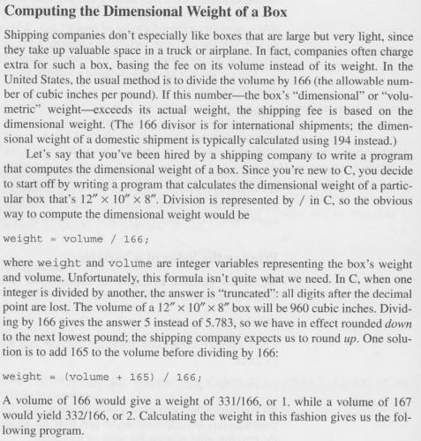

**Solve Hints:**

1. Declare variable and assign const value(Show different type of initialization)

2. Calculate volume

3. Calculate weight( type casting → int/int = int)

4. Print the result

**Modified version:**

1. Instead assigning const value take it from user.

2. Use #define to declare const that divide volume to find weight.

1. **Converting Fahrenheit to Celsius**

Formula: C = ((F-32)*5)/9 [C= Celsius value, F = Fahrenheit value]

1. **C Program to Calculate Area and Circumference of Circle**

Given, r = radius

Pi = value of pi

Formula: Area = pi * r2

Circumference = 2 * pi * r

1. **C Program to Calculate Area of Equilateral Triangle**
2. **C Program to Calculate Area of Right angle Triangle**
3. **C Program to Calculate Area of Rectangle**
4. **C Program to Calculate Area of Square**
5. **C Program to Add Two Integers Entered by User**
6. **C Program to Multiply two Floating Point Numbers**
7. **C Program to Find ASCII Value of Character Entered by User**